**Adjustment for one personnel**:

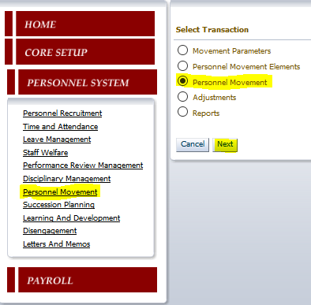

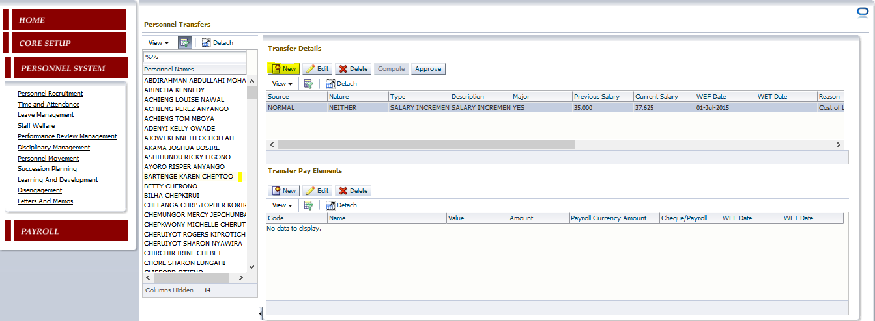

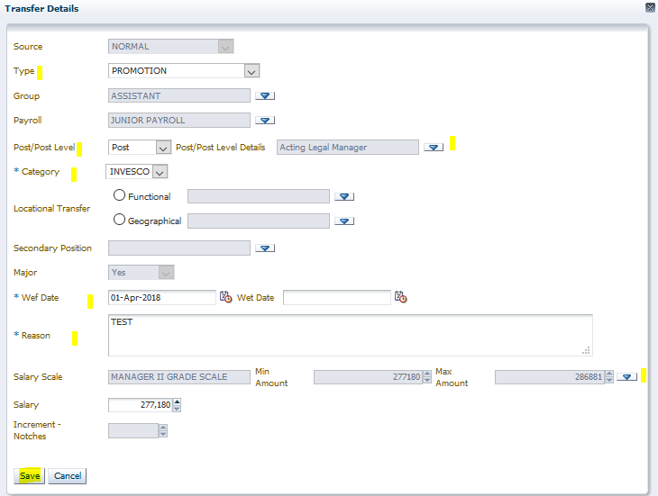

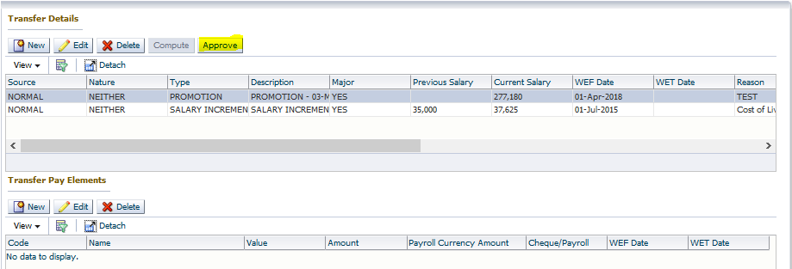

**Multiple Personnel**:

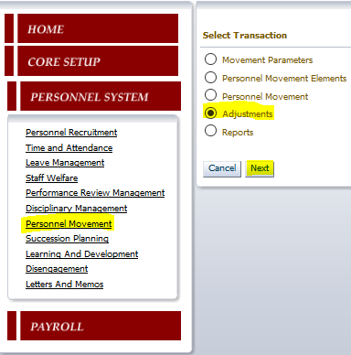

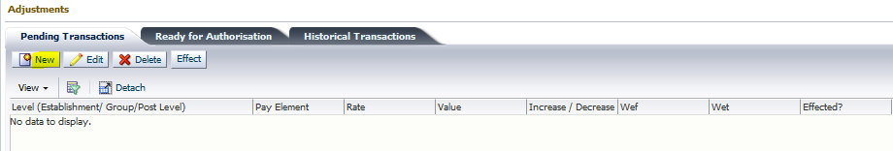

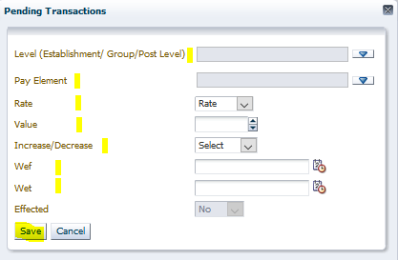

The change can be effected for all personnel in the company, a Group or a Post Level. Select as appropriate from the list below:

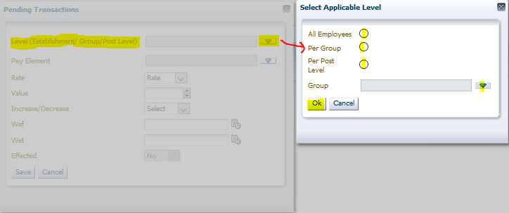

Select the pay element(s)/allowance(s) that you want to adjust for the select group, post level or establishment (entire company) as shown below:

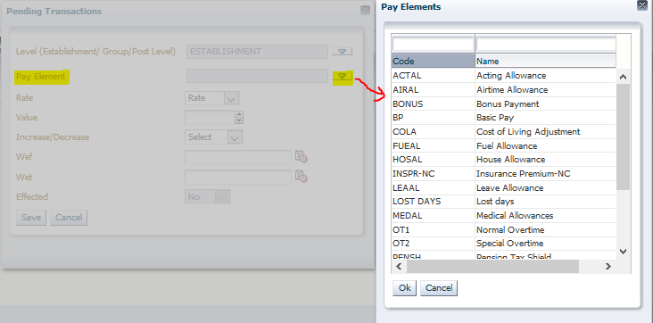

The system lists all pay elements/allowances available in the application. These are adjusted one by one as desired. This is so because sometimes, the rates adjusting different allowances will be different: either per pay element, or per group, per post level etc. Also, note that adjustments from the ground up (adjust allowances, so that they adjust the Gross Pay – which is a function of a number of pay elements).

Define details relating to the adjustment as shown below:

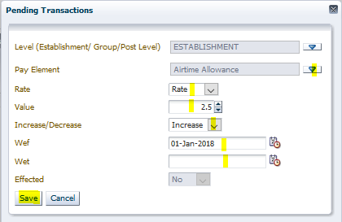

* The adjustment can either be a rate (percentage increase of the current allowance value) or an amount (to be added to the current allowance value)
* Adjustment can either be an increase or a decrease
* Define the date range within which the adjustment is to be effected (WEF Date and WET Date - if this modification is closed-ended), or define a with-effect-from date which dictates the date from which the allowance is applicable for the group, company or post level as defined.
* Save the record

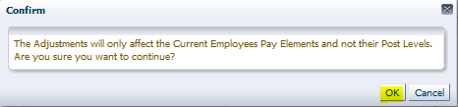

Since this change applies to currently employed personnel, and not the post level allowances as defined for the organization, it will not overwrite the post level pay elements set ups as defined for the organization.

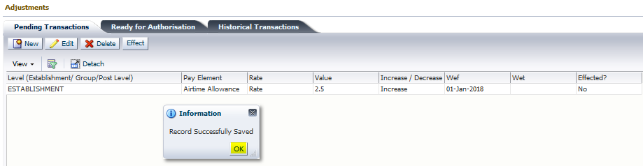

Next, the adjustment is effected, using the “Effect” button above, after which the “ticket” is moved to the next screen – “Ready for Authorization” for approval. The approval can only be done by the personnel defined under the screen “Core Setup >> Administration >> HR Approval Setup >> Salary Adjustment”.

Once this process is complete, the changes will be picked in the payrolls that come after the WET Date defined when doing the adjustment.